**Mechanics: Positive Controls**

Running positive and negative controls is the best practice in any field. At the beginning we will start with positive controls. This will provide confidence to you and others in your abilities. You can find a couple of positive control you can run below:

**Positive control -1:** *Tension-pCa curve from rat soleus muscles*

* When Ken was a postdoc, he ran experiments with Rat Soleus Muscles. These experiments were done at 15C and have resulted in a pCa50 = 5.92, nH = 1.59 [2002 paper](https://www.ncbi.nlm.nih.gov/pmc/articles/PMC1301901/pdf/11806934.pdf)
* We aim to reproduce this result
* Keeping the fiber in a high pCa solution causes it to run down. So our strategy should be to use 7-8 pCa solutions (wisely) and to keep the fiber in an activation solution (anything which has a higher Ca2+ concentration than pCa 9.0) as little as possible.
* Start with getting isometric tensions at pCa 9.0, then pCa 4.5. Now choose a pCa close to the pCa50 which is pCa 6.0. Then, choose two pCa above pCa50 and 2-3 pCa below pCa50. I selected pCa 5.4 and 5.0 for the points above pCa 50. pCa 6.8 and 6.4 and 6.2 for points below pCa50. Finally, collect data at pCa 4.5 to check the rundown of the fiber.
* Collect data from 4-5 fibers.
* Plot the tension-pCa curves and different components of the Hill curves (passive force, active force, pCa50, and nH) to show Ken. Show the y axis starting at 0 except pCa50.
* Note: If you don’t collect data for the pCa 6.8, your graph will not show that great fit at the low force levels

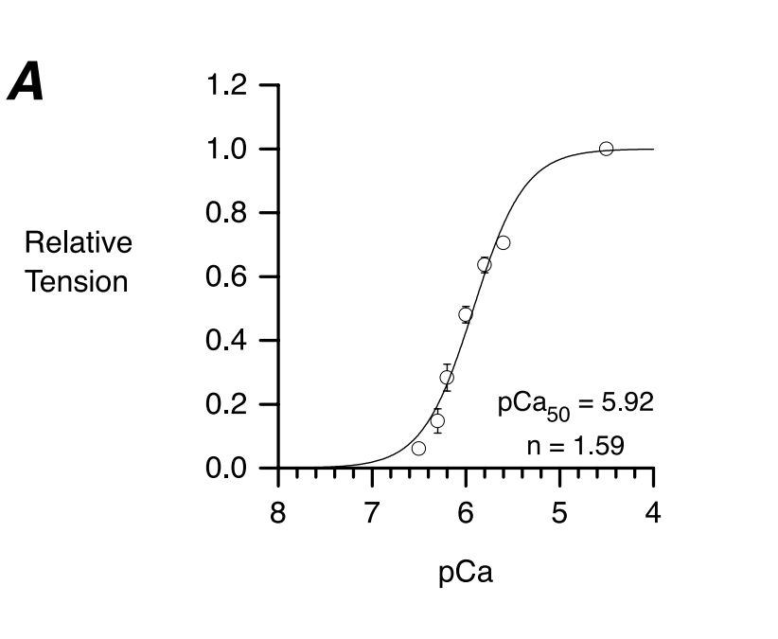

Figure: The tension-pCa curve of rat soleus muscle from Ken’s 2020 paper

**Positive control -2:** *Tension-pCa curve from rat cardiac muscles*

* [Charles Chung ran experiments](https://www.ncbi.nlm.nih.gov/pmc/articles/PMC3942377/) on Rat cardiac tissue at 15C
* He got pCa50 = 5.69, nH = 4.04, active F = 30.4 kN m^-2
* We aim to reproduce this result
* Similarly, use pCa 9.0 and 4.5. Then, one pCa solution nears pCa50, two pCa solution above the pCa50 and 2 or 3 pCa solution below pCa50. I suggest to use pCa 5.7, then randomly pCa 5.4, 5.0, 6.0, 6.2, and 6.4. Finally, collect pCa4.5 to know the run down.
* Collect data from 4-5 fibers.
* Plot the tension-pCa curves and different components of the Hill curves (passive force, active force, pCa50, and nH) to show Ken. Show the y axis starting at 0 except pCa50.

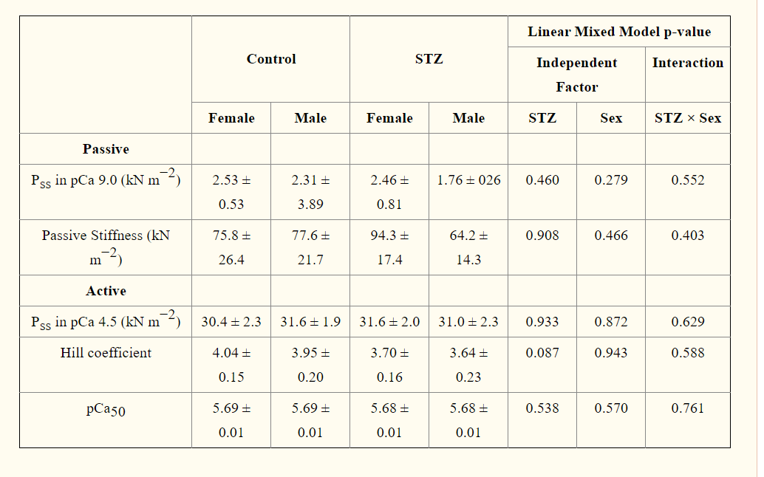

Data presented in Charles’ paper

**Positive control -3***: Tension-pCa curve from human cardiac muscles*

* [Cheaver Blair ran experiments](https://www.ncbi.nlm.nih.gov/pmc/articles/PMC7452203/) with human LV and RV from organ donors and heart failure patients
* He got nH 2.9 and pCa50 = 5.67at 15C
* We aim to reproduce this result
* Similarly, use pCa 9.0 and 4.5. Then, one pCa solution nears pCa50, two pCa solution above the pCa50, and 2-3 pCa solution below pCa50. I suggest to use pCa 5.7, then randomly pCa 5.4, 5.0, 6.0, 6.2, and 6.4. Finally, collect pCa4.5 to know run down.

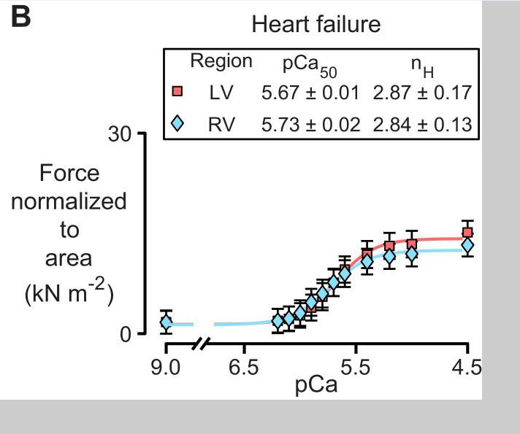

Figure from Cheaver’s LV vs RV paper.